Preliminary Announcement
6th Annual Meeting and Workshops
Vrije Universiteit, Amsterdam

February 26 – March 2, 2002

The Free University campus and the Vrije Universiteit Teaching Hospital are situated in the southern part of the capital, at a point where motorways and public transport facilities converge.  The international airport of Schiphol-Amsterdam is about 10 kilometers away. | 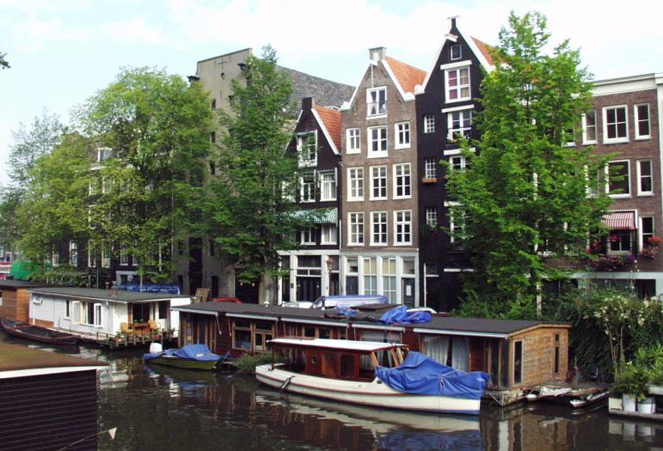

The Biofeedback Foundation of Europe (BFE) promotes greater awareness and training of biofeedback among European researchers, health professionals and educators. The annual meeting provides a scientific session and workshops in the use of self-regulation and biofeedback applications, techniques and technology. Workshop presenters are well-known biofeedback clinicians, who will demonstrate various techniques and applications

Leading international researchers, clinicians and educators will teach in-depth workshops on the use of applied psychophysiology and biofeedback in areas such as physical therapy, repetitive strain injury, panic and anxiety, somatoform disorders, neuromuscular disorders, hyperactivity, attention deficit disorders, peak performance, and stress management.

- The scientific program features lectures, symposia, paper sessions, round table discussion, short courses and poster presentations.
- Exhibition area for commercial and non-profit organizations..
- 1-day workshops and 2-day workshops taught by internationally recognized biofeedback clinicians from Europe and North America.
- Workshop presenters will demonstrate the latest biofeedback techniques and technology for many applications.

The program committee invites you to:
- Attend the workshops to learn clinical and educational applications
- Attend the scientific session to learn about the leading edge of biofeedback research and applications
- Submit proposals for symposia, oral presentations, poster presentations, short courses, and round table discussions.

Cosponsored by:
AAPB (Association for Applied Psychophysiology and Biofeedback) -International Section
ISMA (International Stress Management Association)-Netherland
Gesellschaft für Internationales Streßmanagement & Biofeedback & Coaching

INVITATION TO SUBMIT PROPOSALS FOR SYMPOSIA, ORAL RESENTATIONS,
POSTER PRESENTATIONS, SHORT COURSES AND ROUND TABLES DISCUSSIONS

Submissions for oral presentations, posters, short courses, round tables and symposia can be sent to the BFE, Attn. Scientific Program Committee, P.O. Box 75416, 1070 AK Amsterdam, The Netherlands. Email: Danielle Matto<dmmatto@hetnet.nl>

All presenters whose papers, posters, symposia are accepted will receive a 15% discount on the BFE conference fee. The Scientific Program Committee will notify the authors of acceptance or non-acceptance of their submissions on November 1, 2001.

Submit proposals using the “submission cover sheet.”. Deadlines for submission are:

October 1, 2001 | Deadline for submitting symposia and short courses, round tables
October 15, 2001 | Deadline for submitting oral and poster presentations
January 1, 2002 | Deadline for submitting rapid communication posters.

We look forward to you attendance at the conference and workshops and submissions for the symposia, oral papers, posters, round tables and short courses.

Sincerely,

Erik Peper, Ph.D. (USA) Chair, Advisory Board
Program Committee
Gideon de Haan Netherlands
Johan Fekkes Netherlands
Daniel Hamiel Israel
Hermie Hermens Netherlands
Alexandra Nanke, Germany
Winfried Rief Germany
Ben Rietsma Germany
Ute Strehl Germany
Wytze van der Zwaag Netherlands

GUIDELINES FOR SUBMITTING PROPOSALS

Symposia information (Deadline October 1, 2001):
Symposia are in-depth examinations of a particular topic or issue that incorporates several different viewpoints, aspects or methodologies. The symposium general includes a moderator, three panelists and a discussant.

Symposia Submission Guidelines:
- Title of Symposium
- A short statement of the problem, goals or purpose of the symposium (150 words)
- List of three keywords at the bottom of the symposium statement
- Moderator’s name
- Submission cover sheet
- A 100 word abstract of each presenter’s presentation
- List of three keywords at the bottom of each abstract

Oral Paper or Poster information (Submission deadline: October 15, 2001):
Poster presenters share their work using a combination of written and graphic materials presented on a display board approximately 1 meter by 2 meters (4feet by 8 feet). Posters must be set up by 9 a.m. for the day that they are assigned.

Oral Paper or Poster Submission Guidelines:
- Title of Poster
- A short abstract which contains a summary of the problem, subjects, method, results and discussion (200 words)
- List of three keywords at the bottom of abstract
- Submission cover sheet

Short Course information (Submission deadline: October 1, 2001):
Short courses are lectures and demonstrations by one of more presenters covering detailed information on a specific topic. Short courses are 1 ½ hours in length.

Short Course Submission Guidelines:
- Title of Short Course
- A short abstract which contains a summary of the problem, subjects, method, results and discussion (200 words)
- List of three keywords at the bottom of abstract
- Submission cover sheet

Proposals must be submitted as a Word or WordPerfect file on diskette or email attachment. Please list the format in the email or letter with the diskette (see reverse for Submission format guide).

SUBMISSION FORMAT GUIDE

POSTER & ORAL PRESENTATION
ABTSTRACT FORMAT GUIDE

2 cm. Top margin
2 cm Left margin 2 cm Right margin

Title of the presentation
Skip 1 line
Presenter(s)
Name, title, clinic, country

Co-authors
Skip 2 lines
Summary of the presentation (max. 50 words)
Skip 1 line
Short abstract (max. 200 words, not to exceed 1 page)
Skip 1 line
Communication should be addressed to: Keywords:
Name presenter Keyword 1
Full address Keyword 2
Phone, Fax, Email Keyword 3

SYMPOSIUM PROPOSAL FORMAT GUIDE

2 cm. Top margin
2 cm Left margin 2 cm Right margin

Title of symposium
Skip 1 line
Moderator
Name, title, clinic, country, institutional affiliation
Skip 2 lines
Summary statement of the problem addressed by the symposium and the approaches represented by the panelists (max. 150 words)
Skip 1 line
Paper 1: title, name presenter, abstract ( max. 100 words, not to exceed 1 page)
Skip 1 line
Paper 2: title, name presenter, abstract ( max. 100 words, not to exceed 1 page)
Skip 1 line
Paper 3: title, name presenter, abstract ( max. 100 words, not to exceed 1 page)
Skip 1 line

Discussant
Name, title, clinic, country, institutional affiliation
Skip 1 line

Name, address and affiliation for each presenter

SUBMISSION COVER SHEET

- Type of submission (please indicate):
- Symposium
- Oral paper
- Poster presentation
- Short course

B. Title of presentation:

PS Please send in the abstract as an attachment, see Submission Format Guide

- First author/presenter:
Last name First Name Degree
Institutional Affiliation:
Mailing address:

Phone/Fax /
Email

- Co-author/co-presenter:
Last name First Name Degree
Institutional Affiliation:
Mailing address:

Phone/Fax /
Email

PS Attach the information for additional authors/presenters on separate page

E. Audio visual requirements:
- Slide projector
- Overhead projector
- Computer projector

Submit submission cover sheet and abstract to:
Program Committee BFE
P.O. Box 75416 Email: dmmatto@hetnet.nl
1070 AK Amsterdam Tel: (31) 20 44 22 631
The Netherlands Fax: (31) 20 44 22 632

For BFE use only: Date received
Confirmation mailed
Submission acceptance/rejection mailed

